X760

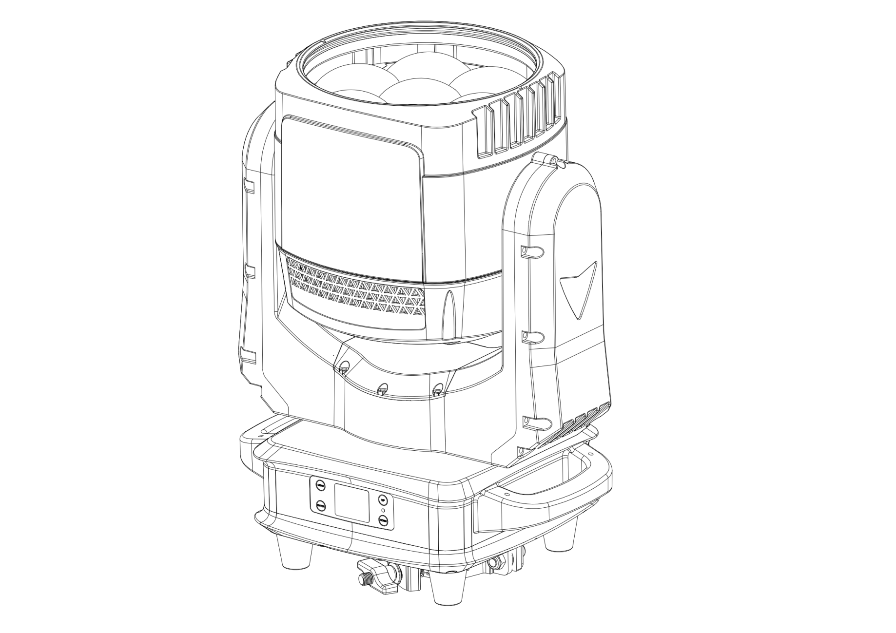

User Manual
- Safety Instructions
Please read the instruction carefully which includes important information about the installation, usage and maintenance.

- Please keep this User Guide for future consultation. If you sell the unit to another user, be sure that they also receive this instruction manual.

- Unpack and check carefully to ensure that there is no transportation damage before using the unit.
- This product is suitable for wet locations. Do not immerse in water.
- DO install and operate by qualified operator.
- DO NOT allow children to operate the fixture.
- Use safety chain when fixing the unit. Handle the unit by carrying its base instead of head only.
- The unit must be installed in a location with adequate ventilation, at least 50cm from adjacent surfaces.
- Be sure that no ventilation slots is blocked, otherwise the unit will be overheated.
- Before operation, ensure that you are connecting this product to the proper voltage in accordance with the specifications in this manual or on the product’s specification label.
- It’s important to ground the yellow/green conductor to earth in order to avoid electric shock.
- Minimum ambient temperature TA: 0℃. Maximum ambient temperature TA: 40℃. Do not operate this product at a lower or higher temperature.
- DO NOT connect the device to any dimmer pack
- Keep flammable materials away from the fixture while operating to avoid fire hazard.
- Make sure the power cord is not crimped or damaged; replace it immediately if damaged
- Unit’s surface temperature may reach up to 65℃. DO NOT touch the housing bare-handed during its operation
- Avoid any flammable liquids, water or metal from entering the unit.
- DO NOT operate in a dirty or dusty environment. DO clean the fixture regularly.
- DO NOT touch any wire during operation as there might be a hazard of electric shock.
- Avoid entanglement of the power cord with other wires.
- The minimum distance to objects/surface must be more than 0.5 meters.
- In the event of serious operating problem, stop using the unit immediately.
- Never turn on and off the unit time after time.
- The housing, the lenses, or the ultraviolet filter must be replaced if they are visibly damaged
- DO NOT open the housing as there are no user serviceable parts inside.
- DO NOT attempt to operate this unit if it becomes damaged. DO NOT attempt any repairs yourself. Repairs carried out by unskilled people can lead to damage or malfunction. Please contact the nearest authorized technical assistance center if needed.
- Disconnect this product from its power source before servicing.
- DO use the original packaging if the device is to be transported.
- Avoid direct eye exposure to the light source while the product is on.
- DO NOT operate this product if you see damage on the housing, shields, or cables. Have the damaged parts replaced by an authorized technician at once.
2.INSTALLATIONS
- installations Note: In order to increase protection, please install the lamp on the sidewalk, outside the seating area, or an area where unauthorized persons may touch the led
- Before installing the fixture on any surface, make sure that the installation area can bear the minimum point load above 10 points of the weight of the equipment. The installation of the fixing device must always be fixed with auxiliary safety accessories (such as a suitable safety rope) Do not stand directly under the equipment when installing, removing, or servicing fixtures
- Ensure thatthis fixture is kept at least 0.5m (1.5 feet) away from any
flammable materials(decorations, etc.)
- Be sure to use and install the supplied safety rope to ensure safety and
prevent accidental damage and/or injury in case the fixture is damaged
Installation point: Overhead installation requires a wealth of experience,
including calculation of working load limits, in-depth understanding of the
installation materials used, and regular safety inspections of all installation
materials and fixtures. If you do not have these qualifications, please do not try to install it yourself. Improper installation can cause personal injury
Before connecting the main power cord to an appropriate wall outlet,make
sure to complete all assembly and installation procedures
3. DMX-512 control connections
Connect the provided XLR cable to the female 3-pin XLR output of your
controller and the other side to the male 3-pin XLR input of the moving head.
You can chain multiple Moving heads be connected together through serial linking. The cable needed should be two core, screened cable with XLR input and output connectors.
For installations where the DMX cable has to run a long distance or is in an
electrically noisy environment, such as in a discotheque, it is recommended to
use a DMX terminator. This helps in preventing corruption of the digital control
signal by electrical noise. The DMX terminator is simply an XLR plug with a 120 Ω resistor connected between pins 2 and 3,which is then plugged into the
output XLR socket of the last fixture in the chain. Please see illustrations below

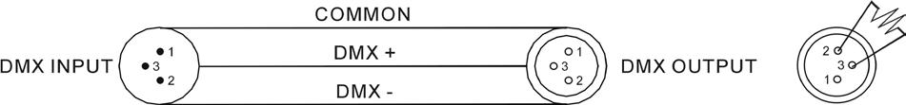
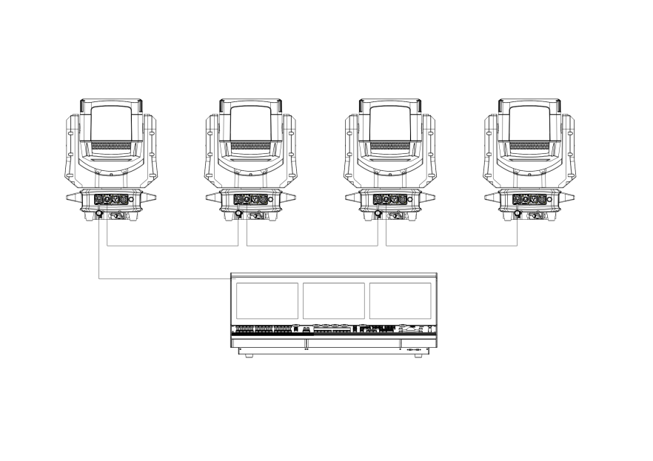

4.Address code setting
If you use a universal DMX controller to control the units, you have to set DMX address from 1 to 512 so that the units can receive DMX signal.
Press the MENU button to enter menu mode, select DMX Settings, press the ENTER button to confirm, use the UP/DOWN button to select DMX Address, press the ENTER button to confirm, the present address will blink in the display, use the UP/DOWN button to adjust the address from 001 to 512, press the ENTER button to store. Press the MENU button back to the last menu or let the unit idle 30 seconds to exit menu mode.Please refer to the following diagram to address your DMX512 channel for the first 4 units.
Channel MODE | UNIT1  ADDERSS | UNIT2  ADDERSS | UNIT3  ADDERSS | UNIT4  ADDERSS
20CH | 1.1 | 1.21 | 1.41 | 1.61
36CH | 1.1 | 1.37 | 1.73 | 1.109
57CH | 1.1 | 1.58 | 1.115 | 1.172
66CH | 1.1 | 1.67 | 1.133 | 1.199
93CH | 1.1 | 1.94 | 1.187 | 1.280
102CH | 1.1 | 1.103 | 1.205 | 1.307
214CH | 1.1 | 1.215 | 2.1 | 2.215

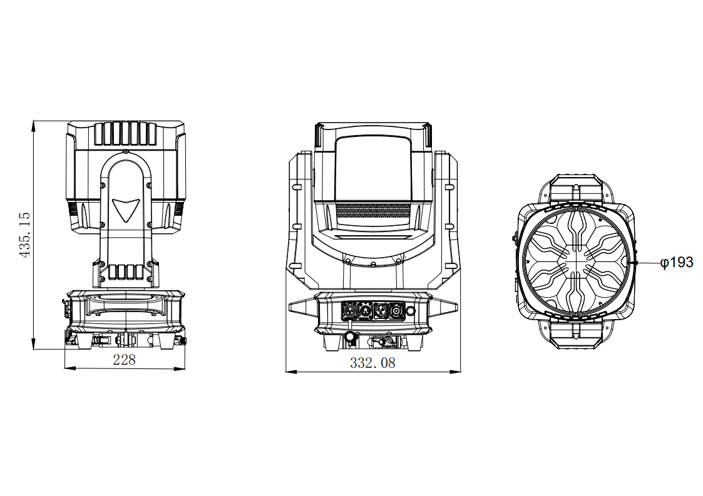
- Fixture size

- LED PIXEL ZONES
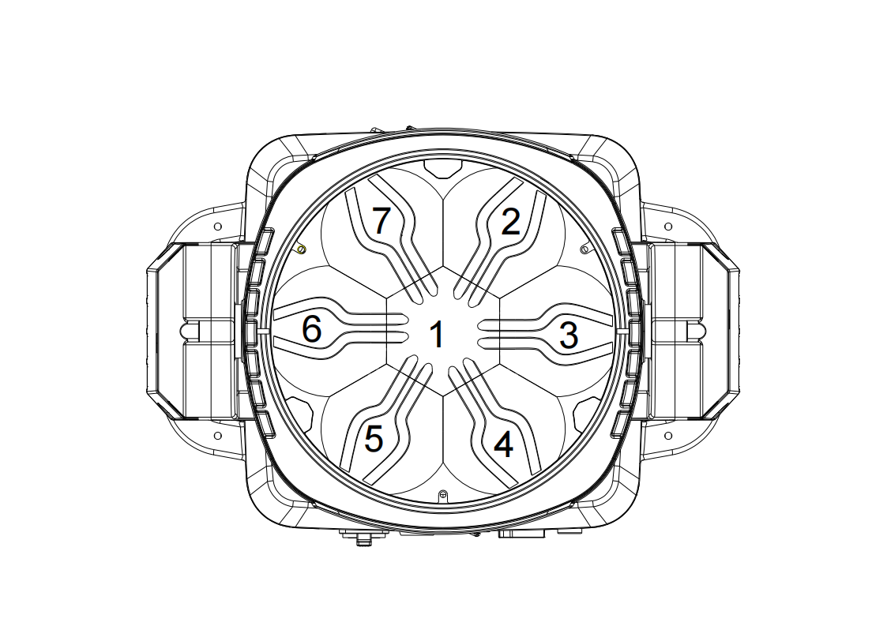
57/66CH pixel segment

93/102CH pixel segment

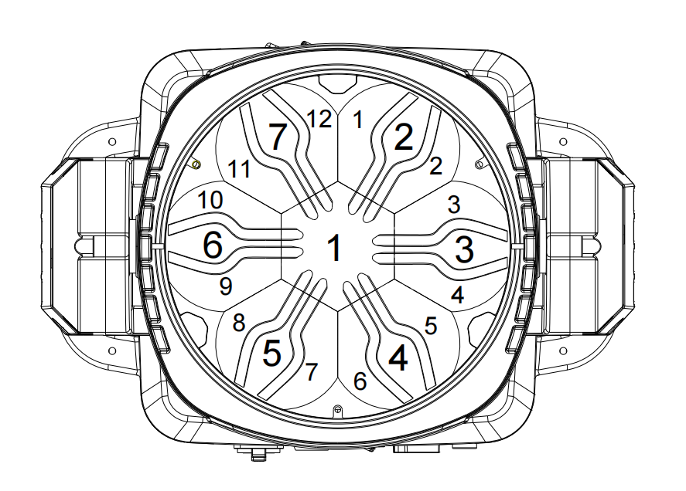

214CH pixel segment
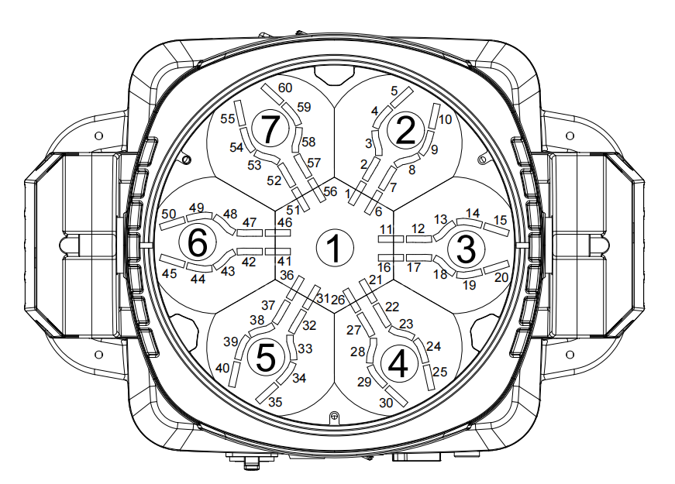

7.LED technical parameters
Input voltage: 100-240V, 50/60Hz
Power consumption: 520W
Power supply: 600W
Main light source: 7PCSx60W RGBW 4IN 1
Auxiliary light 180PCSX0.2W 3535RGB 3IN1
Color System: Excellent Color Macro Effects
Powerful color mixing effect
Rich dynamic color effects
Pixel matrix: Main light 7psc controlled separately
Auxiliary light 12 segment independent control
It can also be controlled by a group of three light beads for point control
LED lifespan:>20000 hours
Zoom angle: 4-60 °
CTO:2500k-8000k
DMX channel: 20/36/57/93/102/214 channels
Operation mode: DMX512、 Automatic, master-slave/ RDM
Dimmer: 0-100% smooth linear dimming
Dimming curves: linear, square law, inverse square law, S-curve
Dimming speed: fast, slow
Strobe: 1-25HZ strong output flicker effect
Adjustable refresh rate from 1K-64KHz
Display: OLED display
Signal input/output: 3-pin and 5-pin waterproof XLR sockets
Power socket: Waterproof power connector input/output
Protection level: IP65
Size: 228x332x435mm
Net weight: 14kg

Feature
The fixture is composed of 7 60W RGBW four-color LEDs as the light source, with excellent color macro effects, making it easy to create powerful beams. Multiple channel modes are available and the LED can be controlled point by point, allowing for flexible color switching. A linear focusing system with a zoom angle of 5 ° -50 °, multiple speed strobe effects, and smooth dimming function from 0 to 100%. Adjustable refresh rate from 1K-64KHz，The backlight is composed of 180 0.2W 3535RGB LEDs, which can create a variety of dynamic lighting effects. The LED can be controlled point by point or divided into 12 stages, fully adapting to different stage application needs..Not only is it compact and lightweight,but it’s X and Y axes also operate with exceptional smoothness and minimal noise

8.Menu Description
Main  Menu | First level  menu | Secondary  menu | Third level  menu
DMX Address | 001-255
Channel Mode | 20/36/57/66/93/  102/214
Run | DMX
Run | Auto
Reset motor | Reset All
Reset motor | Pan/tilt
Reset motor | zoom
Reset motor | Return
settings | dimmer
settings | Master /remote | Master/slave
settings | Dimmer curve | square
settings | Dimmer curve | linear
settings | Dimmer curve | Square Root
settings | Dimmer curve | S-Curve
settings | Pan Reverse | N/Y
settings | Dim speed | Fast/slow
settings | Dim frequency | 1KHZ-64KHZ
settings | Pan Reverse | N/Y
settings | Tilt Reverse | N/Y
settings | Pan Range | Start | 000
settings | Pan Range | End | 255
settings | Tilt Range | Start | 000
settings | Tilt Range | End | 255
settings | Fan Control | Auto
settings | Fan Control | high
settings | Fan Control | medium
settings | Fan Control | low
settings | Fan Control | Ultra low
settings | Lost signal | Keep/dim off
settings | return
DMX Manual | pan | 0-255
DMX Manual | tilt | 0-255
DMX Manual | .... | 0-255
DMX Manual | ... | 0-255
DMX Manual | return
 | Fine Adj | Password:xxx
Adv.settings | Fine Adj Assist | Recover
Adv.settings | Fine Adj Assist | Show backup
Adv.settings | Display set | sleep | 30sec/...
Adv.settings | Display set | Invert | N/Y
Adv.settings | Display set | Display lock | On/off
Adv.settings | Display set | Display | On/off
Adv.settings | language | Eng/中文 | On/off
Adv.settings | Recover set | On/off | On/off
Adv.settings | Return |  | On/off
Factory set | Password:xxx |  | On/off
Info | Dmx monitor | Dmx value | 001-032
Info | Dmx monitor |  | .....
Info | Dmx monitor | Dmx value | 257-282
Info | Dmx monitor | FPS | 000
Info | Dmx monitor | Total chns | 000
Info | Dmx monitor | return
Info | Test | Password:xxx
Info | LED Usage time | Current | Xxxx min
Info | LED Usage time | Total | Xxx hours
Info | LED Usage time | clear
Info | Error | xxxx
Info | Vers | xxxx

- DMX Channel
- 20Channel
20CH | DMX | Explanation
1 |  | Strobe
1 | 0 - 19 | closed
1 | 20 - 49 | open
1 | 50 - 200 | Strobe, slow from fast
1 | 201- 210 | Shutter open
1 | 211- 255 | Random strobe, slow from fast
2 | 0-255 | dimmer
3 | 0-255 | Dimmer fine
4 | 0-255 | Red
5 | 0-255 | Red fine
6 | 0-255 | Green
7 | 0-255 | Green fine
8 | 0-255 | Blue
9 | 0-255 | Blue fine
10 | 0-255 | CTC
11 |  | NO function
12 |  | Color macro
12 | 0 -10 | Open
12 | 11 | Moroccan pink (Lee 790)
12 | 13 | Pink (Lee 157)
12 | 15 | Special rose pink (Lee 332)
12 | 17 | Follies pink (Lee 328)
12 | 19 | Fuchsia pink (Lee 345)
12 | 21 | Surprise pink (Lee 194)
12 | 23 | Congo blue (Lee 181)
12 | 25 | Tokyo blue (Lee 071)
12 | 27 | Deep blue (Lee 120)
12 | 29 | Just blue (Lee 079)
12 | 31 | Medium blue (Lee 132)
12 | 33 | Double CT blue (Lee 200)
12 | 35 | Slate blue (Lee 161)
12 | 37 | Full CT blue (Lee 201)
12 | 39 | Half CT blue (Lee 202)
12 | 41 | Steel blue (Lee 117)
12 | 43 | Lighter blue (Lee 353)
12 | 45 | Light blue (Lee 118)
12 | 47 | Medium blue green (Lee 116)
12 | 49 | Dark green (Lee 124)
12 | 51 | Primary green (Lee 139)
12 | 53 | Moss green (Lee 089)
12 | 55 | Fern green (Lee 122)
12 | 57 | Jas green (Lee 738)
12 | 59 | Lime green (Lee 088)
12 | 61 | Spring yellow (Lee 100)
12 | 63 | Deep amber (Lee 104)
 | 65 | Chrome orange (Lee 179)
 | 67 | Orange (Lee 105)
 | 69 | Gold amber (Lee 021)
 | 71 | Millennium gold (Lee 778)
 | 73 | Deep golden amber (Lee 135)
 | 75 | Flame red (Lee 164)
 | 77 | Red magenta
 | 79 | Medium lavender
 | 81 | Pure white
 | 83 | Pure red
 | 85 | Pure yellow
 | 87 | Pure green
 | 89 | Pure cyan
 | 91 | Pure blue
 | 93 | Pure magenta
 | 95 | Peacock blue (LEE 115)
 | 97 | Dark lavender (LEE 180)
 | 99 | Double CT orange (LEE 287)
 | 101 | Full CT orange (LEE 204)
 | 103 | Half CT orange (LEE 205)
 | 105 | Deep Straw (LEE 015)
 | 107-190 | No function
 |  | Continuous rotation
 | 191 -214 | CW, fast → slow
 | 215 -219 | Stop
 | 220 -243 | CCW slow → fast
 |  | Random colors
 | 244 -247 | Fast
 | 248 -251 | Medium
 | 252 -255 | Slow
13 | 0-255 | Zoom
14 | 0-255 | Zoom fine
15 | 0-255 | pan
16 | 0-255 | Pan fine
17 | 0-255 | tilt
18 | 0-255 | Tilt fine
19 |  | function
19 | 0-9 | No function
19 | 10 - 14 | Reset all
19 | 15 - 16 | No function
19 | 17 | Reset beam
19 | 18 | Reset XY
19 | 19 - 22 | No function
19 | 23 | Linear dimming curve
19 | 24 | Square law dimming curve
19 | 25 | Inverse square law dimming curve
19 | 26 | S-curve dimming curve
19 | 27-51 | No function
19 | 52 | Screen Lock：YES
19 | 53 | Screen Lock：NO
19 | 54 | Auto fan speed
19 | 55 | Full fan speed
19 | 56 | Medium fan speed
19 | 57 | Low fan speed
19 | 58 | Ultra-low fan speed
19 | 59-60 | No function
19 | 61 | Dimmer speed:fast
19 | 62 | Dimmer speed:slow
19 | 63-64 | No function
19 | 65 | Signal clear
19 | 66 | Signal keep
19 | 67-255 | No function
20 |  | LED frequency
20 | 0-9 | No function
20 | 10 | 1KHz LED frequency
20 | 11 | 2KHz LED frequency
20 | 12 | 3KHz LED frequency
20 | 。。。 | 。。。
20 | 。。。 | 。。。
20 | 70 | 61KHz LED frequency
20 | 71 | 62KHz LED frequency
20 | 72 | 63KHz LED frequency
20 | 73-127 | No function
20 | 128 | 16KHz LED frequency（default）
20 | 129-254 | No function
20 | 255 | 64KHz LED frequency

36Channel
36CH | DMX | Explanation
1 |  | Strobe
1 | 0 - 19 | closed
1 | 20 - 49 | open
1 | 50 - 200 | Strobe, slow from fast
1 | 201- 210 | Shutter open
1 | 211- 255 | Random strobe, slow from fast
2 | 0-255 | dimmer
3 | 0-255 | Dimmer fine
4 | 0-255 | Red
5 | 0-255 | Red fine
6 | 0-255 | Green
7 | 0-255 | Green fine
8 | 0-255 | Blue
9 | 0-255 | Blue fine
10 | 0-255 | CTC
11 |  | NO function
12 |  | Color macro
12 | 0 -10 | Open
12 | 11 | Moroccan pink (Lee 790)
12 | 13 | Pink (Lee 157)
12 | 15 | Special rose pink (Lee 332)
12 | 17 | Follies pink (Lee 328)
12 | 19 | Fuchsia pink (Lee 345)
12 | 21 | Surprise pink (Lee 194)
12 | 23 | Congo blue (Lee 181)
12 | 25 | Tokyo blue (Lee 071)
12 | 27 | Deep blue (Lee 120)
12 | 29 | Just blue (Lee 079)
12 | 31 | Medium blue (Lee 132)
12 | 33 | Double CT blue (Lee 200)
12 | 35 | Slate blue (Lee 161)
12 | 37 | Full CT blue (Lee 201)
12 | 39 | Half CT blue (Lee 202)
12 | 41 | Steel blue (Lee 117)
12 | 43 | Lighter blue (Lee 353)
12 | 45 | Light blue (Lee 118)
12 | 47 | Medium blue green (Lee 116)
12 | 49 | Dark green (Lee 124)
12 | 51 | Primary green (Lee 139)
12 | 53 | Moss green (Lee 089)
12 | 55 | Fern green (Lee 122)
12 | 57 | Jas green (Lee 738)
12 | 59 | Lime green (Lee 088)
12 | 61 | Spring yellow (Lee 100)
12 | 63 | Deep amber (Lee 104)
 | 65 | Chrome orange (Lee 179)
 | 67 | Orange (Lee 105)
 | 69 | Gold amber (Lee 021)
 | 71 | Millennium gold (Lee 778)
 | 73 | Deep golden amber (Lee 135)
 | 75 | Flame red (Lee 164)
 | 77 | Red magenta
 | 79 | Medium lavender
 | 81 | Pure white
 | 83 | Pure red
 | 85 | Pure yellow
 | 87 | Pure green
 | 89 | Pure cyan
 | 91 | Pure blue
 | 93 | Pure magenta
 | 95 | Peacock blue (LEE 115)
 | 97 | Dark lavender (LEE 180)
 | 99 | Double CT orange (LEE 287)
 | 101 | Full CT orange (LEE 204)
 | 103 | Half CT orange (LEE 205)
 | 105 | Deep Straw (LEE 015)
 | 107-190 | No function
 |  | Continuous rotation
 | 191 -214 | CW, fast → slow
 | 215 -219 | Stop
 | 220 -243 | CCW slow → fast
 |  | Random colors
 | 244 -247 | Fast
 | 248 -251 | Medium
 | 252 -255 | Slow
13 | 0-255 | Zoom
14 | 0-255 | Zoom fine
15 | 0-255 | pan
16 | 0-255 | Pan fine
17 | 0-255 | tilt
18 | 0-255 | Tilt fine
19 |  | function
19 | 0-9 | No function
19 | 10 - 14 | Reset all
19 | 15 - 16 | No function
19 | 17 | Reset beam
19 | 18 | Reset XY
19 | 19 - 22 | No function
19 | 23 | Linear dimming curve
19 | 24 | Square law dimming curve
19 | 25 | Inverse square law dimming curve
19 | 26 | S-curve dimming curve
19 | 27-51 | No function
19 | 52 | Dis Lock：YES
19 | 53 | dis Lock：NO
19 | 54 | Auto fan speed
19 | 55 | Full fan speed
19 | 56 | Medium fan speed
19 | 57 | Low fan speed
19 | 58 | Ultra-low fan speed
19 | 59-60 | No function
19 | 61 | Dimmer speed:fast
19 | 62 | Dimmer speed:slow
19 | 63-64 | No function
19 | 65 | Signal clear
19 | 66 | Signal keep
19 | 67-255 | No function
20 |  | LED frequency
20 | 0-9 | No function
20 | 10 | 1KHz LED frequency
20 | 11 | 2KHz LED frequency
20 | 12 | 3KHz LED frequency
20 | 。。。 | 。。。
20 | 。。。 | 。。。
20 | 。。。 | 。。。
20 | 70 | 61KHz LED frequency
20 | 71 | 62KHz LED frequency
20 | 72 | 63KHz LED frequency
20 | 73-127 | No function
20 | 128 | 16KHz LED frequency（default）
20 | 129-254 | No function
20 | 255 | 64KHz LED frequency
21 |  | NO function
22 |  | Main LED effect selection
23 |  | Main LED Effect speed
23 | 0 - 126 | Effect reversed fast → slow
23 | 127- 129 | Effect stops
23 | 130- 255 | Effect forward slow → fast
24 |  | Backlight LED effect selection
25 |  | Backlight LED Effect speed
25 | 0 - 126 | Effect reversed fast → slow
25 | 127- 129 | Effect stops
25 | 130- 255 | Effect forward slow → fast
26 |  | Effect Offset shift
26 | 0 | NO Function
26 | 1 | Offset shift10°
26 | 2 | Offset shift20°
26 | 3 | Offset shift30°
26 | 。。。 | 。。。
26 | 。。。 | 。。。
26 | 。。。 | 。。。
26 | 33 | Offset shift330°
26 | 34 | Offset shift340°
26 | 35 | Offset shift350°
26 | 36 | Synchronized: all fixtures start FX cycles at same time
26 | 37 - 100 | No function
26 | 101- 120 | Random start (Channel 23 controls overall speed)
26 | 121- 140 | Random duration
26 | 141- 255 | No function
27 |  | Backlight LED strobe
27 | 0 - 19 | closed
27 | 20 - 49 | open
27 | 50 - 200 | Strobe, slow from fast
27 | 201- 210 | Shutter open
27 | 211- 255 | Random strobe, slow from fast
28 | 0-255 | dimmer
29 | 0-255 | Dimmer fine
30 | 0-255 | Red
31 | 0-255 | Green
32 | 0-255 | blue
33 | 0-255 | CTC
34 | 0-255 | NO function
35 |  | Color macro
35 | 0 -10 | Open
35 | 11 | Moroccan pink (Lee 790)
35 | 13 | Pink (Lee 157)
35 | 15 | Special rose pink (Lee 332)
35 | 17 | Follies pink (Lee 328)
35 | 19 | Fuchsia pink (Lee 345)
35 | 21 | Surprise pink (Lee 194)
35 | 23 | Congo blue (Lee 181)
35 | 25 | Tokyo blue (Lee 071)
35 | 27 | Deep blue (Lee 120)
35 | 29 | Just blue (Lee 079)
35 | 31 | Medium blue (Lee 132)
35 | 33 | Double CT blue (Lee 200)
35 | 35 | Slate blue (Lee 161)
35 | 37 | Full CT blue (Lee 201)
35 | 39 | Half CT blue (Lee 202)
35 | 41 | Steel blue (Lee 117)
35 | 43 | Lighter blue (Lee 353)
35 | 45 | Light blue (Lee 118)
35 | 47 | Medium blue green (Lee 116)
35 | 49 | Dark green (Lee 124)
35 | 51 | Primary green (Lee 139)
35 | 53 | Moss green (Lee 089)
35 | 55 | Fern green (Lee 122)
35 | 57 | Jas green (Lee 738)
35 | 59 | Lime green (Lee 088)
35 | 61 | Spring yellow (Lee 100)
35 | 63 | Deep amber (Lee 104)
35 | 65 | Chrome orange (Lee 179)
35 | 67 | Orange (Lee 105)
35 | 69 | Gold amber (Lee 021)
35 | 71 | Millennium gold (Lee 778)
35 | 73 | Deep golden amber (Lee 135)
35 | 75 | Flame red (Lee 164)
35 | 77 | Red magenta
35 | 79 | Medium lavender
35 | 81 | Pure white
35 | 83 | Pure red
35 | 85 | Pure yellow
35 | 87 | Pure green
35 | 89 | Pure cyan
35 | 91 | Pure blue
35 | 93 | Pure magenta
35 | 95 | Peacock blue (LEE 115)
35 | 97 | Dark lavender (LEE 180)
35 | 99 | Double CT orange (LEE 287)
35 | 101 | Full CT orange (LEE 204)
35 | 103 | Half CT orange (LEE 205)
35 | 105 | Deep Straw (LEE 015)
35 | 107-190 | No function
35 |  | Continuous rotation
35 | 191 -214 | CW, fast → slow
35 | 215 -219 | Stop
35 | 220 -243 | CCW slow → fast
35 |  | Random colors
35 | 244 -247 | Fast
35 | 248 -251 | Medium
35 | 252 -255 | Slow
36 |  | No function

57Channel
57CH | DMX | Explanation
1 |  | Strobe
1 | 0 - 19 | closed
1 | 20 - 49 | open
1 | 50 - 200 | Strobe, slow from fast
1 | 201- 210 | Shutter open
1 | 211- 255 | Random strobe, slow from fast
2 | 0-255 | dimmer
3 | 0-255 | Dimmer fine
4 | 0-255 | Red
5 | 0-255 | Red fine
6 | 0-255 | Green
7 | 0-255 | Green fine
8 | 0-255 | Blue
9 | 0-255 | Blue fine
10 | 0-255 | CTC
11 |  | NO function
12 |  | Color macro
12 | 0 -10 | Open
12 | 11 | Moroccan pink (Lee 790)
12 | 13 | Pink (Lee 157)
12 | 15 | Special rose pink (Lee 332)
12 | 17 | Follies pink (Lee 328)
12 | 19 | Fuchsia pink (Lee 345)
12 | 21 | Surprise pink (Lee 194)
12 | 23 | Congo blue (Lee 181)
12 | 25 | Tokyo blue (Lee 071)
12 | 27 | Deep blue (Lee 120)
12 | 29 | Just blue (Lee 079)
12 | 31 | Medium blue (Lee 132)
12 | 33 | Double CT blue (Lee 200)
12 | 35 | Slate blue (Lee 161)
12 | 37 | Full CT blue (Lee 201)
12 | 39 | Half CT blue (Lee 202)
12 | 41 | Steel blue (Lee 117)
12 | 43 | Lighter blue (Lee 353)
12 | 45 | Light blue (Lee 118)
12 | 47 | Medium blue green (Lee 116)
12 | 49 | Dark green (Lee 124)
12 | 51 | Primary green (Lee 139)
12 | 53 | Moss green (Lee 089)
12 | 55 | Fern green (Lee 122)
12 | 57 | Jas green (Lee 738)
12 | 59 | Lime green (Lee 088)
12 | 61 | Spring yellow (Lee 100)
12 | 63 | Deep amber (Lee 104)
 | 65 | Chrome orange (Lee 179)
 | 67 | Orange (Lee 105)
 | 69 | Gold amber (Lee 021)
 | 71 | Millennium gold (Lee 778)
 | 73 | Deep golden amber (Lee 135)
 | 75 | Flame red (Lee 164)
 | 77 | Red magenta
 | 79 | Medium lavender
 | 81 | Pure white
 | 83 | Pure red
 | 85 | Pure yellow
 | 87 | Pure green
 | 89 | Pure cyan
 | 91 | Pure blue
 | 93 | Pure magenta
 | 95 | Peacock blue (LEE 115)
 | 97 | Dark lavender (LEE 180)
 | 99 | Double CT orange (LEE 287)
 | 101 | Full CT orange (LEE 204)
 | 103 | Half CT orange (LEE 205)
 | 105 | Deep Straw (LEE 015)
 | 107-190 | No function
 |  | Continuous rotation
 | 191 -214 | CW, fast → slow
 | 215 -219 | Stop
 | 220 -243 | CCW slow → fast
 |  | Random colors
 | 244 -247 | Fast
 | 248 -251 | Medium
 | 252 -255 | Slow
13 | 0-255 | Zoom
14 | 0-255 | Zoom fine
15 | 0-255 | pan
16 | 0-255 | Pan fine
17 | 0-255 | tilt
18 | 0-255 | Tilt fine
19 |  | function
19 | 0-9 | No function
19 | 10 - 14 | Reset all
19 | 15 - 16 | No function
19 | 17 | Reset beam
19 | 18 | Reset XY
19 | 19 - 22 | No function
19 | 23 | Linear dimming curve
19 | 24 | Square law dimming curve
19 | 25 | Inverse square law dimming curve
19 | 26 | S-curve dimming curve
19 | 27-51 | No function
19 | 52 | Screen Lock：YES
19 | 53 | Screen Lock：NO
19 | 54 | Auto fan speed
19 | 55 | Full fan speed
19 | 56 | Medium fan speed
19 | 57 | Low fan speed
19 | 58 | Ultra-low fan speed
19 | 59-60 | No function
19 | 61 | Dimmer speed:fast
19 | 62 | Dimmer speed:slow
19 | 63-64 | No function
19 | 65 | Signal clear
19 | 66 | Signal keep
19 | 67-255 | No function
20 |  | LED frequency
20 | 0-9 | No function
20 | 10 | 1KHz LED frequency
20 | 11 | 2KHz LED frequency
20 | 12 | 3KHz LED frequency
20 | 。。。 | 。。。
20 | 。。。 | 。。。
20 | 。。。 | 。。。
20 | 70 | 61KHz LED frequency
20 | 71 | 62KHz LED frequency
20 | 72 | 63KHz LED frequency
20 | 73-127 | No function
20 | 128 | 16KHz LED frequency（default）
20 | 129-254 | No function
20 | 255 | 64KHz LED frequency
21 |  | NO function
22 |  | Main LED effect selection
23 |  | Main LED Effect speed
23 | 0 - 126 | Effect reversed fast → slow
23 | 127- 129 | Effect stops
23 | 13 - 255 | Effect forward slow → fast
24 |  | Backlight LED effect selection
25 |  | Backlight LED Effect speed
25 | 0 - 126 | Effect reversed fast → slow
25 | 127- 129 | Effect stops
25 | 13 - 255 | Effect forward slow → fast
26 |  | Effect Offset shift
26 | 0 | NO Function
26 | 1 | Offset shift10°
26 | 2 | Offset shift20°
26 | 3 | Offset shift30°
26 | 。。。 | 。。。
26 | 。。。 | 。。。
26 | 。。。 | 。。。
26 | 33 | Offset shift330°
26 | 34 | Offset shift340°
26 | 35 | Offset shift350°
26 | 36 | Synchronized: all fixtures start FX cycles at same time
26 | 37 - 100 | No function
26 | 101- 120 | Random start (Channel 23 controls overall speed)
26 | 121- 140 | Random duration
26 | 141- 255 | No function
27 |  | Backlight LED strobe
27 | 0 - 19 | closed
27 | 20 - 49 | open
27 | 50 - 200 | Strobe, slow from fast
27 | 201- 210 | Shutter open
27 | 211- 255 | Random strobe, slow from fast
28 | 0-255 | dimmer
29 | 0-255 | Dimmer fine
30 | 0-255 | Red
31 | 0-255 | Green
32 | 0-255 | blue
33 | 0-255 | CTC
34 | 0-255 | NO function
35 |  | Color macro
35 | 0 -10 | Open
35 | 11 | Moroccan pink (Lee 790)
35 | 13 | Pink (Lee 157)
35 | 15 | Special rose pink (Lee 332)
35 | 17 | Follies pink (Lee 328)
35 | 19 | Fuchsia pink (Lee 345)
35 | 21 | Surprise pink (Lee 194)
35 | 23 | Congo blue (Lee 181)
35 | 25 | Tokyo blue (Lee 071)
35 | 27 | Deep blue (Lee 120)
35 | 29 | Just blue (Lee 079)
35 | 31 | Medium blue (Lee 132)
35 | 33 | Double CT blue (Lee 200)
35 | 35 | Slate blue (Lee 161)
35 | 37 | Full CT blue (Lee 201)
35 | 39 | Half CT blue (Lee 202)
35 | 41 | Steel blue (Lee 117)
35 | 43 | Lighter blue (Lee 353)
35 | 45 | Light blue (Lee 118)
35 | 47 | Medium blue green (Lee 116)
35 | 49 | Dark green (Lee 124)
35 | 51 | Primary green (Lee 139)
35 | 53 | Moss green (Lee 089)
35 | 55 | Fern green (Lee 122)
35 | 57 | Jas green (Lee 738)
35 | 59 | Lime green (Lee 088)
35 | 61 | Spring yellow (Lee 100)
35 | 63 | Deep amber (Lee 104)
35 | 65 | Chrome orange (Lee 179)
35 | 67 | Orange (Lee 105)
35 | 69 | Gold amber (Lee 021)
35 | 71 | Millennium gold (Lee 778)
35 | 73 | Deep golden amber (Lee 135)
35 | 75 | Flame red (Lee 164)
35 | 77 | Red magenta
35 | 79 | Medium lavender
35 | 81 | Pure white
35 | 83 | Pure red
35 | 85 | Pure yellow
35 | 87 | Pure green
35 | 89 | Pure cyan
35 | 91 | Pure blue
35 | 93 | Pure magenta
35 | 95 | Peacock blue (LEE 115)
35 | 97 | Dark lavender (LEE 180)
35 | 99 | Double CT orange (LEE 287)
35 | 101 | Full CT orange (LEE 204)
35 | 103 | Half CT orange (LEE 205)
35 | 105 | Deep Straw (LEE 015)
35 | 107-190 | No function
35 |  | Continuous rotation
35 | 191 -214 | CW, fast → slow
35 | 215 -219 | Stop
35 | 220 -243 | CCW slow → fast
35 |  | Random colors
35 | 244 -247 | Fast
35 | 248 -251 | Medium
35 | 252 -255 | Slow
36 |  | No function
37 | 0-255 | Pixel 1 Red
38 | 0-255 | Pixel 1 green
39 | 0-255 | Pixel 1 blue
。。 | 0-255 | 。。。
。。 | 0-255 | 。。。
。。 | 0-255 | 。。。
55 | 0-255 | Pixel 7 Red
56 | 0-255 | Pixel 7 green
57 | 0-255 | Pixel 7 blue

66Channel
66CH | DMX | Explanation
1 |  | Strobe
1 | 0 - 19 | closed
1 | 20 - 49 | open
1 | 50 - 200 | Strobe, slow from fast
1 | 201- 210 | Shutter open
1 | 211- 255 | Random strobe, slow from fast
2 | 0-255 | dimmer
3 | 0-255 | Dimmer fine
4 | 0-255 | Red
5 | 0-255 | Red fine
6 | 0-255 | Green
7 | 0-255 | Green fine
8 | 0-255 | Blue
9 | 0-255 | Blue fine
10 | 0-255 | white
11 | 0-255 | White fine
12 | 0-255 | CTC
13 |  | NO function
14 |  | Color macro
14 | 0 -10 | Open
14 | 11 | Moroccan pink (Lee 790)
14 | 13 | Pink (Lee 157)
14 | 15 | Special rose pink (Lee 332)
14 | 17 | Follies pink (Lee 328)
14 | 19 | Fuchsia pink (Lee 345)
14 | 21 | Surprise pink (Lee 194)
14 | 23 | Congo blue (Lee 181)
14 | 25 | Tokyo blue (Lee 071)
14 | 27 | Deep blue (Lee 120)
14 | 29 | Just blue (Lee 079)
14 | 31 | Medium blue (Lee 132)
14 | 33 | Double CT blue (Lee 200)
14 | 35 | Slate blue (Lee 161)
14 | 37 | Full CT blue (Lee 201)
14 | 39 | Half CT blue (Lee 202)
14 | 41 | Steel blue (Lee 117)
14 | 43 | Lighter blue (Lee 353)
14 | 45 | Light blue (Lee 118)
14 | 47 | Medium blue green (Lee 116)
14 | 49 | Dark green (Lee 124)
14 | 51 | Primary green (Lee 139)
14 | 53 | Moss green (Lee 089)
14 | 55 | Fern green (Lee 122)
14 | 57 | Jas green (Lee 738)
14 | 59 | Lime green (Lee 088)
14 | 61 | Spring yellow (Lee 100)
14 | 63 | Deep amber (Lee 104)
 | 65 | Chrome orange (Lee 179)
 | 67 | Orange (Lee 105)
 | 69 | Gold amber (Lee 021)
 | 71 | Millennium gold (Lee 778)
 | 73 | Deep golden amber (Lee 135)
 | 75 | Flame red (Lee 164)
 | 77 | Red magenta
 | 79 | Medium lavender
 | 81 | Pure white
 | 83 | Pure red
 | 85 | Pure yellow
 | 87 | Pure green
 | 89 | Pure cyan
 | 91 | Pure blue
 | 93 | Pure magenta
 | 95 | Peacock blue (LEE 115)
 | 97 | Dark lavender (LEE 180)
 | 99 | Double CT orange (LEE 287)
 | 101 | Full CT orange (LEE 204)
 | 103 | Half CT orange (LEE 205)
 | 105 | Deep Straw (LEE 015)
 | 107-190 | No function
 |  | Continuous rotation
 | 191 -214 | CW, fast → slow
 | 215 -219 | Stop
 | 220 -243 | CCW slow → fast
 |  | Random colors
 | 244 -247 | Fast
 | 248 -251 | Medium
 | 252 -255 | Slow
15 | 0-255 | Zoom
16 | 0-255 | Zoom fine
17 | 0-255 | pan
18 | 0-255 | Pan fine
19 | 0-255 | tilt
20 | 0-255 | Tilt fine
21 |  | function
21 | 0-9 | No function
21 | 10 - 14 | Reset all
21 | 15 - 16 | No function
21 | 17 | Reset beam
21 | 18 | Reset XY
21 | 19 - 22 | No function
21 | 23 | Linear dimming curve
21 | 24 | Square law dimming curve
21 | 25 | Inverse square law dimming curve
21 | 26 | S-curve dimming curve
21 | 27-51 | No function
21 | 52 | Screen Lock：YES
21 | 53 | Screen Lock：NO
21 | 54 | Auto fan speed
21 | 55 | Full fan speed
21 | 56 | Medium fan speed
21 | 57 | Low fan speed
21 | 58 | Ultra-low fan speed
21 | 59-60 | No function
21 | 61 | Dimmer speed:fast
21 | 62 | Dimmer speed:slow
21 | 63-64 | No function
21 | 65 | Signal clear
21 | 66 | Signal keep
21 | 67-255 | No function
22 |  | LED frequency
22 | 0-9 | No function
22 | 10 | 1KHz LED frequency
22 | 11 | 2KHz LED frequency
22 | 12 | 3KHz LED frequency
22 | 。。。 | 。。。
22 | 。。。 | 。。。
22 | 。。。 | 。。。
22 | 70 | 61KHz LED frequency
22 | 71 | 62KHz LED frequency
22 | 72 | 63KHz LED frequency
22 | 73-127 | No function
22 | 128 | 16KHz LED frequency（default）
22 | 129-254 | No function
22 | 255 | 63KHz LED frequency
23 |  | NO function
24 |  | Main LED effect selection
25 |  | Main LED Effect speed
25 | 0 - 126 | Effect reversed fast → slow
25 | 127- 129 | Effect stops
25 | 13 - 255 | Effect forward slow → fast
26 |  | Backlight LED effect selection
27 |  | Backlight LED Effect speed
27 | 0 - 126 | Effect reversed fast → slow
27 | 127- 129 | Effect stops
27 | 13 - 255 | Effect forward slow → fast
28 |  | Effect Offset shift
28 | 0 | NO Function
28 | 1 | Offset shift10°
28 | 2 | Offset shift20°
28 | 3 | Offset shift30°
28 | 。。。 | 。。。
28 | 。。。 | 。。。
28 | 。。。 | 。。。
28 | 33 | Offset shift330°
28 | 34 | Offset shift340°
28 | 35 | Offset shift350°
28 | 36 | Synchronized: all fixtures start FX cycles at same time
28 | 37-100 | No function
28 | 101-120 | Random start (Channel 23 controls overall speed)
28 | 121-140 | Random duration
28 | 141-255 | No function
29 |  | Backlight LED strobe
29 | 0 - 19 | closed
29 | 20 - 49 | open
29 | 50 - 200 | Strobe, slow from fast
29 | 201- 210 | Shutter open
29 | 211- 255 | Random strobe, slow from fast
30 | 0-255 | dimmer
31 | 0-255 | Dimmer fine
32 | 0-255 | Red
33 | 0-255 | Green
34 | 0-255 | blue
35 | 0-255 | CTC
36 | 0-255 | NO function
37 |  | Color macro
37 | 0 -10 | Open
37 | 11 | Moroccan pink (Lee 790)
37 | 13 | Pink (Lee 157)
37 | 15 | Special rose pink (Lee 332)
37 | 17 | Follies pink (Lee 328)
37 | 19 | Fuchsia pink (Lee 345)
37 | 21 | Surprise pink (Lee 194)
37 | 23 | Congo blue (Lee 181)
37 | 25 | Tokyo blue (Lee 071)
37 | 27 | Deep blue (Lee 120)
37 | 29 | Just blue (Lee 079)
37 | 31 | Medium blue (Lee 132)
37 | 33 | Double CT blue (Lee 200)
37 | 35 | Slate blue (Lee 161)
37 | 37 | Full CT blue (Lee 201)
37 | 39 | Half CT blue (Lee 202)
37 | 41 | Steel blue (Lee 117)
37 | 43 | Lighter blue (Lee 353)
37 | 45 | Light blue (Lee 118)
37 | 47 | Medium blue green (Lee 116)
37 | 49 | Dark green (Lee 124)
37 | 51 | Primary green (Lee 139)
37 | 53 | Moss green (Lee 089)
37 | 55 | Fern green (Lee 122)
37 | 57 | Jas green (Lee 738)
37 | 59 | Lime green (Lee 088)
37 | 61 | Spring yellow (Lee 100)
37 | 63 | Deep amber (Lee 104)
37 | 65 | Chrome orange (Lee 179)
37 | 67 | Orange (Lee 105)
37 | 69 | Gold amber (Lee 021)
37 | 71 | Millennium gold (Lee 778)
37 | 73 | Deep golden amber (Lee 135)
37 | 75 | Flame red (Lee 164)
37 | 77 | Red magenta
37 | 79 | Medium lavender
37 | 81 | Pure white
37 | 83 | Pure red
37 | 85 | Pure yellow
37 | 87 | Pure green
37 | 89 | Pure cyan
37 | 91 | Pure blue
37 | 93 | Pure magenta
37 | 95 | Peacock blue (LEE 115)
37 | 97 | Dark lavender (LEE 180)
37 | 99 | Double CT orange (LEE 287)
37 | 101 | Full CT orange (LEE 204)
37 | 103 | Half CT orange (LEE 205)
37 | 105 | Deep Straw (LEE 015)
37 | 107-190 | No function
37 |  | Continuous rotation
37 | 191 -214 | CW, fast → slow
37 | 215 -219 | Stop
37 | 220 -243 | CCW slow → fast
37 |  | Random colors
37 | 244 -247 | Fast
37 | 248 -251 | Medium
37 | 252 -255 | Slow
38 |  | No function
39 | 0-255 | Pixel 1 Red
40 | 0-255 | Pixel 1 green
41 | 0-255 | Pixel 1 blue
42 | 0-255 | Pixel 1 white
。。 | 0-255 | 。。。
。。 | 0-255 | 。。。
。。 | 0-255 | 。。。
。。 | 0-255 | 。。。
63 | 0-255 | Pixel 7 Red
64 | 0-255 | Pixel 7 green
65 | 0-255 | Pixel 7 blue
66 | 0-255 | Pixel 7 white

93Channel
93CH | DMX | Explanation
1 |  | Strobe
1 | 0 - 19 | closed
1 | 20 - 49 | open
1 | 50 - 200 | Strobe, slow from fast
1 | 201- 210 | Shutter open
1 | 211- 255 | Random strobe, slow from fast
2 | 0-255 | dimmer
3 | 0-255 | Dimmer fine
4 | 0-255 | Red
5 | 0-255 | Red fine
6 | 0-255 | Green
7 | 0-255 | Green fine
8 | 0-255 | Blue
9 | 0-255 | Blue fine
10 | 0-255 | CTC
11 |  | NO function
12 |  | Color macro
12 | 0 -10 | Open
12 | 11 | Moroccan pink (Lee 790)
12 | 13 | Pink (Lee 157)
12 | 15 | Special rose pink (Lee 332)
12 | 17 | Follies pink (Lee 328)
12 | 19 | Fuchsia pink (Lee 345)
12 | 21 | Surprise pink (Lee 194)
12 | 23 | Congo blue (Lee 181)
12 | 25 | Tokyo blue (Lee 071)
12 | 27 | Deep blue (Lee 120)
12 | 29 | Just blue (Lee 079)
12 | 31 | Medium blue (Lee 132)
12 | 33 | Double CT blue (Lee 200)
12 | 35 | Slate blue (Lee 161)
12 | 37 | Full CT blue (Lee 201)
12 | 39 | Half CT blue (Lee 202)
12 | 41 | Steel blue (Lee 117)
12 | 43 | Lighter blue (Lee 353)
12 | 45 | Light blue (Lee 118)
12 | 47 | Medium blue green (Lee 116)
12 | 49 | Dark green (Lee 124)
12 | 51 | Primary green (Lee 139)
12 | 53 | Moss green (Lee 089)
12 | 55 | Fern green (Lee 122)
12 | 57 | Jas green (Lee 738)
12 | 59 | Lime green (Lee 088)
12 | 61 | Spring yellow (Lee 100)
12 | 63 | Deep amber (Lee 104)
 | 65 | Chrome orange (Lee 179)
 | 67 | Orange (Lee 105)
 | 69 | Gold amber (Lee 021)
 | 71 | Millennium gold (Lee 778)
 | 73 | Deep golden amber (Lee 135)
 | 75 | Flame red (Lee 164)
 | 77 | Red magenta
 | 79 | Medium lavender
 | 81 | Pure white
 | 83 | Pure red
 | 85 | Pure yellow
 | 87 | Pure green
 | 89 | Pure cyan
 | 91 | Pure blue
 | 93 | Pure magenta
 | 95 | Peacock blue (LEE 115)
 | 97 | Dark lavender (LEE 180)
 | 99 | Double CT orange (LEE 287)
 | 101 | Full CT orange (LEE 204)
 | 103 | Half CT orange (LEE 205)
 | 105 | Deep Straw (LEE 015)
 | 107-190 | No function
 |  | Continuous rotation
 | 191 -214 | CW, fast → slow
 | 215 -219 | Stop
 | 220 -243 | CCW slow → fast
 |  | Random colors
 | 244 -247 | Fast
 | 248 -251 | Medium
 | 252 -255 | Slow
13 | 0-255 | Zoom
14 | 0-255 | Zoom fine
15 | 0-255 | pan
16 | 0-255 | Pan fine
17 | 0-255 | tilt
18 | 0-255 | Tilt fine
19 |  | function
19 | 0-9 | No function
19 | 10 - 14 | Reset all
19 | 15 - 16 | No function
19 | 17 | Reset beam
19 | 18 | Reset XY
19 | 19 - 22 | No function
19 | 23 | Linear dimming curve
19 | 24 | Square law dimming curve
19 | 25 | Inverse square law dimming curve
19 | 26 | S-curve dimming curve
19 | 27-51 | No function
19 | 52 | Screen Lock：YES
19 | 53 | Screen Lock：NO
19 | 54 | Auto fan speed
19 | 55 | Full fan speed
19 | 56 | Medium fan speed
19 | 57 | Low fan speed
19 | 58 | Ultra-low fan speed
19 | 59-60 | No function
19 | 61 | Dimmer speed:fast
19 | 62 | Dimmer speed:slow
19 | 63-64 | No function
19 | 65 | Signal clear
19 | 66 | Signal keep
19 | 67-255 | No function
20 |  | LED frequency
20 | 0-9 | No function
20 | 10 | 1KHz LED frequency
20 | 11 | 2KHz LED frequency
20 | 12 | 3KHz LED frequency
20 | 。。。 | 。。。
20 | 。。。 | 。。。
20 | 。。。 | 。。。
20 | 70 | 61KHz LED frequency
20 | 71 | 62KHz LED frequency
20 | 72 | 63KHz LED frequency
20 | 73-127 | No function
20 | 128 | 16KHz LED frequency（default）
20 | 129-254 | No function
20 | 255 | 63KHz LED frequency
21 |  | NO function
22 |  | Main LED effect selection
23 |  | Main LED Effect speed
23 | 0 - 126 | Effect reversed fast → slow
23 | 127- 129 | Effect stops
23 | 13 - 255 | Effect forward slow → fast
24 |  | Backlight LED effect selection
25 |  | Backlight LED Effect speed
25 | 0 - 126 | Effect reversed fast → slow
25 | 127- 129 | Effect stops
25 | 13 - 255 | Effect forward slow → fast
26 |  | Effect Offset shift
26 | 0 | NO Function
26 | 1 | Offset shift10°
26 | 2 | Offset shift20°
26 | 3 | Offset shift30°
26 | 。。。 | 。。。
26 | 。。。 | 。。。
26 | 。。。 | 。。。
26 | 33 | Offset shift330°
26 | 34 | Offset shift340°
26 | 35 | Offset shift350°
26 | 36 | Synchronized: all fixtures start FX cycles at same time
26 | 37-100 | No function
26 | 101-120 | Random start (Channel 23 controls overall speed)
26 | 121-140 | Random duration
26 | 141-255 | No function
27 |  | Backlight LED strobe
27 | 0 - 19 | closed
27 | 20 - 49 | open
27 | 50 - 200 | Strobe, slow from fast
27 | 201- 210 | Shutter open
27 | 211- 255 | Random strobe, slow from fast
28 | 0-255 | dimmer
29 | 0-255 | Dimmer fine
30 | 0-255 | Red
31 | 0-255 | Green
32 | 0-255 | blue
33 | 0-255 | CTC
34 | 0-255 | NO function
35 |  | Color macro
35 | 0 -10 | Open
35 | 11 | Moroccan pink (Lee 790)
35 | 13 | Pink (Lee 157)
35 | 15 | Special rose pink (Lee 332)
35 | 17 | Follies pink (Lee 328)
35 | 19 | Fuchsia pink (Lee 345)
35 | 21 | Surprise pink (Lee 194)
35 | 23 | Congo blue (Lee 181)
35 | 25 | Tokyo blue (Lee 071)
35 | 27 | Deep blue (Lee 120)
35 | 29 | Just blue (Lee 079)
35 | 31 | Medium blue (Lee 132)
35 | 33 | Double CT blue (Lee 200)
35 | 35 | Slate blue (Lee 161)
35 | 37 | Full CT blue (Lee 201)
35 | 39 | Half CT blue (Lee 202)
35 | 41 | Steel blue (Lee 117)
35 | 43 | Lighter blue (Lee 353)
35 | 45 | Light blue (Lee 118)
35 | 47 | Medium blue green (Lee 116)
35 | 49 | Dark green (Lee 124)
35 | 51 | Primary green (Lee 139)
35 | 53 | Moss green (Lee 089)
35 | 55 | Fern green (Lee 122)
35 | 57 | Jas green (Lee 738)
35 | 59 | Lime green (Lee 088)
35 | 61 | Spring yellow (Lee 100)
35 | 63 | Deep amber (Lee 104)
35 | 65 | Chrome orange (Lee 179)
35 | 67 | Orange (Lee 105)
35 | 69 | Gold amber (Lee 021)
35 | 71 | Millennium gold (Lee 778)
35 | 73 | Deep golden amber (Lee 135)
35 | 75 | Flame red (Lee 164)
35 | 77 | Red magenta
35 | 79 | Medium lavender
35 | 81 | Pure white
35 | 83 | Pure red
35 | 85 | Pure yellow
35 | 87 | Pure green
35 | 89 | Pure cyan
35 | 91 | Pure blue
35 | 93 | Pure magenta
35 | 95 | Peacock blue (LEE 115)
35 | 97 | Dark lavender (LEE 180)
35 | 99 | Double CT orange (LEE 287)
35 | 101 | Full CT orange (LEE 204)
35 | 103 | Half CT orange (LEE 205)
35 | 105 | Deep Straw (LEE 015)
35 | 107-190 | No function
35 |  | Continuous rotation
35 | 191 -214 | CW, fast → slow
35 | 215 -219 | Stop
35 | 220 -243 | CCW slow → fast
35 |  | Random colors
35 | 244 -247 | Fast
35 | 248 -251 | Medium
35 | 252 -255 | Slow
36 |  | No function
37 | 0-255 | Pixel 1 Red
38 | 0-255 | Pixel 1 green
39 | 0-255 | Pixel 1 blue
。。 | 0-255 | 。。。
。。 | 0-255 | 。。。
。。 | 0-255 | 。。。
55 | 0-255 | Pixel 7 Red
56 | 0-255 | Pixel 7 green
57 | 0-255 | Pixel 7 blue
58 | 0-255 | Back light 1Red
59 | 0-255 | Back light 1 green
60 | 0-255 | Back light 1 blue
。。 | 0-255 | 。。。
。。 | 0-255 | 。。。
。。 | 0-255 | 。。。
91 | 0-255 | Back light 12 Red
92 | 0-255 | Back light 12 green
93 | 0-255 | Back light 12 blue

102Channel
102CH | DMX | Explanation
1 |  | Strobe
1 | 0 - 19 | closed
1 | 20 - 49 | open
1 | 50 - 200 | Strobe, slow from fast
1 | 201- 210 | Shutter open
1 | 211- 255 | Random strobe, slow from fast
2 | 0-255 | dimmer
3 | 0-255 | Dimmer fine
4 | 0-255 | Red
5 | 0-255 | Red fine
6 | 0-255 | Green
7 | 0-255 | Green fine
8 | 0-255 | Blue
9 | 0-255 | Blue fine
10 | 0-255 | white
11 | 0-255 | White fine
12 | 0-255 | CTC
13 |  | NO function
14 |  | Color macro
14 | 0 -10 | Open
14 | 11 | Moroccan pink (Lee 790)
14 | 13 | Pink (Lee 157)
14 | 15 | Special rose pink (Lee 332)
14 | 17 | Follies pink (Lee 328)
14 | 19 | Fuchsia pink (Lee 345)
14 | 21 | Surprise pink (Lee 194)
14 | 23 | Congo blue (Lee 181)
14 | 25 | Tokyo blue (Lee 071)
14 | 27 | Deep blue (Lee 120)
14 | 29 | Just blue (Lee 079)
14 | 31 | Medium blue (Lee 132)
14 | 33 | Double CT blue (Lee 200)
14 | 35 | Slate blue (Lee 161)
14 | 37 | Full CT blue (Lee 201)
14 | 39 | Half CT blue (Lee 202)
14 | 41 | Steel blue (Lee 117)
14 | 43 | Lighter blue (Lee 353)
14 | 45 | Light blue (Lee 118)
14 | 47 | Medium blue green (Lee 116)
14 | 49 | Dark green (Lee 124)
14 | 51 | Primary green (Lee 139)
14 | 53 | Moss green (Lee 089)
14 | 55 | Fern green (Lee 122)
14 | 57 | Jas green (Lee 738)
14 | 59 | Lime green (Lee 088)
14 | 61 | Spring yellow (Lee 100)
14 | 63 | Deep amber (Lee 104)
 | 65 | Chrome orange (Lee 179)
 | 67 | Orange (Lee 105)
 | 69 | Gold amber (Lee 021)
 | 71 | Millennium gold (Lee 778)
 | 73 | Deep golden amber (Lee 135)
 | 75 | Flame red (Lee 164)
 | 77 | Red magenta
 | 79 | Medium lavender
 | 81 | Pure white
 | 83 | Pure red
 | 85 | Pure yellow
 | 87 | Pure green
 | 89 | Pure cyan
 | 91 | Pure blue
 | 93 | Pure magenta
 | 95 | Peacock blue (LEE 115)
 | 97 | Dark lavender (LEE 180)
 | 99 | Double CT orange (LEE 287)
 | 101 | Full CT orange (LEE 204)
 | 103 | Half CT orange (LEE 205)
 | 105 | Deep Straw (LEE 015)
 | 107-190 | No function
 |  | Continuous rotation
 | 191 -214 | CW, fast → slow
 | 215 -219 | Stop
 | 220 -243 | CCW slow → fast
 |  | Random colors
 | 244 -247 | Fast
 | 248 -251 | Medium
 | 252 -255 | Slow
15 | 0-255 | Zoom
16 | 0-255 | Zoom fine
17 | 0-255 | pan
18 | 0-255 | Pan fine
19 | 0-255 | tilt
20 | 0-255 | Tilt fine
21 |  | function
21 | 0-9 | No function
21 | 10 - 14 | Reset all
21 | 15 - 16 | No function
21 | 17 | Reset beam
21 | 18 | Reset XY
21 | 19 - 22 | No function
21 | 23 | Linear dimming curve
21 | 24 | Square law dimming curve
21 | 25 | Inverse square law dimming curve
21 | 26 | S-curve dimming curve
21 | 27-51 | No function
21 | 52 | Screen Lock：YES
21 | 53 | Screen Lock：NO
21 | 54 | Auto fan speed
21 | 55 | Full fan speed
21 | 56 | Medium fan speed
21 | 57 | Low fan speed
21 | 58 | Ultra-low fan speed
21 | 59-60 | No function
21 | 61 | Dimmer speed:fast
21 | 62 | Dimmer speed:slow
21 | 63-64 | No function
21 | 65 | Signal clear
21 | 66 | Signal keep
21 | 67-255 | No function
22 |  | LED frequency
22 | 0-9 | No function
22 | 10 | 1KHz LED frequency
22 | 11 | 2KHz LED frequency
22 | 12 | 3KHz LED frequency
22 | 。。。 | 。。。
22 | 。。。 | 。。。
22 | 。。。 | 。。。
22 | 70 | 61KHz LED frequency
22 | 71 | 62KHz LED frequency
22 | 72 | 63KHz LED frequency
22 | 73-127 | No function
22 | 128 | 16KHz LED frequency（default）
22 | 129-254 | No function
22 | 255 | 63KHz LED frequency
23 |  | NO function
24 |  | Main LED effect selection
25 |  | Main LED Effect speed
25 | 0 - 126 | Effect reversed fast → slow
25 | 127- 129 | Effect stops
25 | 13 - 255 | Effect forward slow → fast
26 |  | Backlight LED effect selection
27 |  | Backlight LED Effect speed
27 | 0 - 126 | Effect reversed fast → slow
27 | 127- 129 | Effect stops
27 | 13 - 255 | Effect forward slow → fast
28 |  | Effect Offset shift
28 | 0 | NO Function
28 | 1 | Offset shift10°
28 | 2 | Offset shift20°
28 | 3 | Offset shift30°
28 | 。。。 | 。。。
28 | 。。。 | 。。。
28 | 。。。 | 。。。
28 | 33 | Offset shift330°
28 | 34 | Offset shift340°
28 | 35 | Offset shift350°
28 | 36 | Synchronized: all fixtures start FX cycles at same time
28 | 37-100 | No function
28 | 101-120 | Random start (Channel 23 controls overall speed)
28 | 121-140 | Random duration
28 | 141-255 | No function
29 |  | Backlight LED strobe
29 | 0 - 19 | closed
29 | 20 - 49 | open
29 | 50 - 200 | Strobe, slow from fast
29 | 201- 210 | Shutter open
29 | 211- 255 | Random strobe, slow from fast
30 | 0-255 | dimmer
31 | 0-255 | Dimmer fine
32 | 0-255 | Red
33 | 0-255 | Green
34 | 0-255 | blue
35 | 0-255 | CTC
36 | 0-255 | NO function
37 |  | Color macro
37 | 0 -10 | Open
37 | 11 | Moroccan pink (Lee 790)
37 | 13 | Pink (Lee 157)
37 | 15 | Special rose pink (Lee 332)
37 | 17 | Follies pink (Lee 328)
37 | 19 | Fuchsia pink (Lee 345)
37 | 21 | Surprise pink (Lee 194)
37 | 23 | Congo blue (Lee 181)
37 | 25 | Tokyo blue (Lee 071)
37 | 27 | Deep blue (Lee 120)
37 | 29 | Just blue (Lee 079)
37 | 31 | Medium blue (Lee 132)
37 | 33 | Double CT blue (Lee 200)
37 | 35 | Slate blue (Lee 161)
37 | 37 | Full CT blue (Lee 201)
37 | 39 | Half CT blue (Lee 202)
37 | 41 | Steel blue (Lee 117)
37 | 43 | Lighter blue (Lee 353)
37 | 45 | Light blue (Lee 118)
37 | 47 | Medium blue green (Lee 116)
37 | 49 | Dark green (Lee 124)
37 | 51 | Primary green (Lee 139)
37 | 53 | Moss green (Lee 089)
37 | 55 | Fern green (Lee 122)
37 | 57 | Jas green (Lee 738)
37 | 59 | Lime green (Lee 088)
37 | 61 | Spring yellow (Lee 100)
37 | 63 | Deep amber (Lee 104)
37 | 65 | Chrome orange (Lee 179)
37 | 67 | Orange (Lee 105)
37 | 69 | Gold amber (Lee 021)
37 | 71 | Millennium gold (Lee 778)
37 | 73 | Deep golden amber (Lee 135)
37 | 75 | Flame red (Lee 164)
37 | 77 | Red magenta
37 | 79 | Medium lavender
37 | 81 | Pure white
37 | 83 | Pure red
37 | 85 | Pure yellow
37 | 87 | Pure green
37 | 89 | Pure cyan
37 | 91 | Pure blue
37 | 93 | Pure magenta
37 | 95 | Peacock blue (LEE 115)
37 | 97 | Dark lavender (LEE 180)
37 | 99 | Double CT orange (LEE 287)
37 | 101 | Full CT orange (LEE 204)
37 | 103 | Half CT orange (LEE 205)
37 | 105 | Deep Straw (LEE 015)
37 | 107-190 | No function
37 |  | Continuous rotation
37 | 191 -214 | CW, fast → slow
37 | 215 -219 | Stop
37 | 220 -243 | CCW slow → fast
37 |  | Random colors
37 | 244 -247 | Fast
37 | 248 -251 | Medium
37 | 252 -255 | Slow
38 |  | No function
39 | 0-255 | Pixel 1 Red
40 | 0-255 | Pixel 1 green
41 | 0-255 | Pixel 1 blue
42 | 0-255 | Pixel 1 white
。。 | 0-255 | 。。。
。。 | 0-255 | 。。。
。。 | 0-255 | 。。。
。。 | 0-255 | 。。。
63 | 0-255 | Pixel 7 Red
64 | 0-255 | Pixel 7 green
65 | 0-255 | Pixel 7 blue
66 | 0-255 | Pixel 7 white
67 | 0-255 | Back light 1Red
68 | 0-255 | Back light 1 green
69 | 0-255 | Back light 1 blue
。。 | 0-255 | 。。。
。。 | 0-255 | 。。。
。。 | 0-255 | 。。。
100 | 0-255 | Back light 12Red
101 | 0-255 | Back light 12 green
102 | 0-255 | Back light 12 blue

214Channel
102CH | DMX | Explanation
1 | 0-255 | X
2 | 0-255 | Y
3 | 0-255 | ZOOM
4 |  | Strobe
4 | 0 - 19 | closed
4 | 20 - 49 | open
4 | 50 - 200 | Strobe, slow from fast
4 | 201- 210 | Shutter open
4 | 211- 255 | Random strobe, slow from fast
5 | 0-255 | dimmer
6 | 0-255 | Red 1
7 | 0-255 | Green 1
8 | 0-255 | Blue 1
9 | 0-255 | White 1
。。 | 0-255 | 。。。
。。 | 0-255 | 。。。
。。 | 0-255 | 。。。
。。 | 0-255 | 。。。
30 | 0-255 | Red 7
31 | 0-255 | Green 7
32 | 0-255 | Blue 7
33 | 0-255 | White 7
34 | 0-255 | Back light Red 1
35 | 0-255 | Back light Green 1
36 | 0-255 | Back light Blue 1
37 | 0-255 | 。。。
。。 | 0-255 | 。。。
。。 | 0-255 | 。。。
。。 | 0-255
211 | 0-255 | Back light Red 60
212 | 0-255 | Back light Green 60
213 | 0-255 | Back light Blue 60
214 |  | function
214 | 0-9 | No function
214 | 10 - 14 | Reset all
214 | 15 - 16 | No function
214 | 17 | Reset beam
214 | 18 | Reset XY
214 | 19 - 22 | No function
214 | 23 | Linear dimming curve
214 | 24 | Square law dimming curve
214 | 25 | Inverse square law dimming curve
214 | 26 | S-curve dimming curve
214 | 27-51 | No function
214 | 52 | Screen Lock：YES
214 | 53 | Screen Lock：NO
214 | 54 | Auto fan speed
214 | 55 | Full fan speed
214 | 56 | Medium fan speed
214 | 57 | Low fan speed
214 | 58 | Ultra-low fan speed
214 | 59-60 | No function
214 | 61 | Dimmer speed:fast
214 | 62 | Dimmer speed:slow
214 | 63-64 | No function
214 | 65 | Signal clear
214 | 66 | Signal keep
214 | 67-255 | No function

10.Trouble shooting
Following are a few common problems that may occur during operation. Here are some suggestions for easy troubleshooting:

The unit does not work, no light and the fan does not work
Check the connection of power and main fuse.
Measure the mains voltage on the main connector.
Check the power on LED.

Not responding to DMX controller
DMX LED should be on. If not, check DMX connectors, cables to see if link properly.
If the DMX LED is on and no response to the channel, check the address settings and DMX polarity.
If you have intermittent DMX signal problems, check the pins on connectors or on PCB of the unit or the previous one.
Try to use another DMX controller.
Check if the DMX cables run near or run alongside to high voltage cables that may cause damage or interference to DMX interface circuit.

One of the channels is not working well

The stepper motor might be damaged or the cable connected to the PCB is broken.

